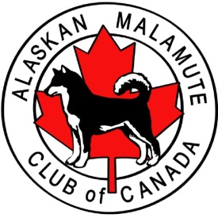
Judging & Event Schedule

ALASKAN MALAMUTE CLUB OF CANADA
National Specialty
Specialty Conformation Show
Veteran Sweepstakes
Junior Handling

July 3, 2015

St. John’s Recreational Center
Buckmaster’s Circle, St. John’s, Newfoundland

Lunch will be delivered at 12:00 p.m. courtesy of the support of exhibitors from our fundraising matches.

VETERAN SWEEPSTAKES Time: 1:30
Judge: David Piercey
7-10 M – 3
7-10 F – 2
13+ F – 1

JUNIOR HANDLING Time: 2:00
Judge: Kathleen Corkum

OBEDIENCE MATCH Time: 2:15
Judge: Paul Oslach
Pre Novice 1
Novice 1

RALLY MATCH Time: 2:30
Judge: Paul Oslach
Intermediate 2
Advanced 3

SPECIALTY Time: 3:30
Judge: Terry Carter
VM – 1, VF – 3
SM – 3, SF – 3

FAN FAVOURITE
Exhibitors and spectators will have an opportunity to vote for their TOP DOG. Cast your ballot at the AMCC info booth. The winner will be announced and presented with their rosette and prize at the banquet!

Like Malamutes, We’re all about Being Social!

Specialty Banquet, Friday July 3

7:00 p.m. It’s time to refuel at the Rocket Room.
Cash bar on site. $40 AMCC exhibitors.
RSVP: Pitcher.jill@gmail.com

Fish and Fairies, Saturday, july 4

7:00 p.m. You’re invited to a night of Seafood, Songs and Stories of Newfoundland in the woods of Seal Cove, but we best keep the fairies away. Newfoundland is known for these mischievous sprites, so you best turn your clothes inside out - and we’ll fill your pockets with Hard Tack (bread). Choice of Lobster or Steak. Selection of Sides and Salads. $10 per person.
RSVP: Pitcher.jill@gmail.com

Haunted Hike, Sunday, July 5

8:30 p.m. Come see a darker side of the Oldest City in North America on this 1.15 hour private walking tour through the downtown area. Limited space available. $10 AMCC/NKC exhibitors. Meet at the West Entrance to the Anglican Cathedral on Church Hill.

